Dear Sirs,

Further to our recent conversation, I am sending our price-list in which own products are represented.
Please draw your attention to our core products.
1. The main product of the enterprise is cheese. The assortment of semi-hard cheese includes nearly 30 names with various fat content and term of ripening. Cheese is produced in euroblocks (500x300x100 mm 15 kg), in round heads (11-15xD24-36; 7,2-8 kg) and rectangular bars (25-30x12-15x8-13, 3,9 – 4,8 kg).

At present cheese can be packaged in flow pack wrapper in modified atmosphere (bars from 250 till 350 grams). Enterprise also produces sliced cheese packing in thermoforming in rigid film. (The pack has a reclosable lid formed inline)
2. Butter (weighted and180 grams packaged).
3. Whey powder with degree of demineralization 50%, 70%, 90%.
Main advantages of our production:
1. Niche specialization. For us product and process quality are more important than product quantity. The main product of the enterprise is cheese. Its production takes 80% of the total production. Our main task is to maintain reputation for producing a high-quality product .
2. Maintenance of supply regularity supply. Our main purpose is to satisfy the demands of our customers. The estimate annual production of cheese is 4200 MT, of butter is more than 1000 MT and of demineralized whey powder is 3200 MT. Nearly 60% of it are intended for export.
3. Highest standards of quality. At our factory there is an accredited industrial laboratory, where the most modern equipment is installed. All production is certificated. The quality of production depends generally on the quality of incoming raw materials. Milk is delivered to the factory from the best 14 agricultural sectors of Vitebsk region. OJSC «Verkhnedvinsk butter-cheese plant» helps agricultural complexes to equip local laboratories, gets for them express tests for identification of inhibitors, carries out trainings for experts.
The quality of the products produced at «Verkhnedvinsk cheese-butter plant» has been estimated not only by customers but also by specialists at different exhibitions and contests of different levels. The products have been awarded with top prizes and received highest scores for sustainable high quality. The plant has gold medals and diplomas achieved at local, Russian and international exhibitions.
At the moment the enterprise is entitled to deliver its products to any country in Europe. Our major trade partners are companies of the Customs Union (Russia and Kazakhstan) but we’re willing to expand our markets and find reliable partners in other countries.
We invite you to the mutually profitable partnership.
We are ready for the new forms of cooperation and will consider commercial offers from potential investors.
The enterprise can give you samples for comparative analysis of yours utilizable materials.
Payment terms: 100% prepayment or irrevocable confirmed L/C.
Besides direct contracts our products can be bought by auction held by OJSC «Belarusian universal commodity exchange» (http://butb.by/engl/).
Minimum consignment for shipment from the warehouse of the enterprise is 20 tons.

Contacts:
OJSC «Verkhnedvinsk butter-cheese plant»
+375215153210 – reception.
+3752971330127 – Chief of marketing department Tsyro Svetlana
+375215152111 – Marketing department
http::// yancheese.by
e-mail: vmsz@yancheese.by,
vkrupenko@inbox.ru

Kindly acknowledge the pricelist on the 8 pages and reply as soon as possible in case you are interested.
Best regards,
Tsyro Svetlana

PRICE-LIST from 26.01.2016
List of items produced |  |  |  |  |  | Shelf life | Price per kilo, no VAT included, FСА delivery basis. USD
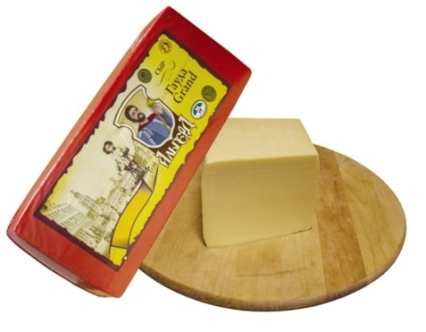 |  | Cheese “Gouda Grand”  Fat content in dry solids 45% min. |  |  |  | 180 days at temperature 0-4⁰C | 3,3
It is a yellow Dutch cheese, made from cow’s milk. Colour is smooth gold yellow. The Cheese has small irregular eyes in section. It has elastic soft consistence and moderately slightly sour cheese taste.
Term of cheese ripening – 30 days.
Produсt code 0406909909 Bar-code 4811208005348
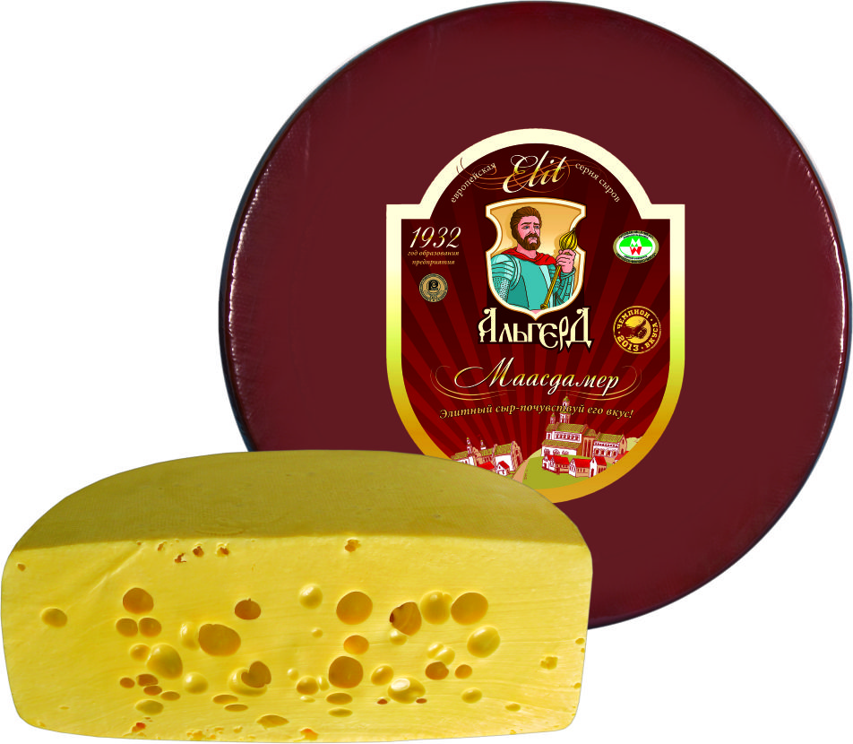 |  |  | Cheese “Maasdamer”(round head)  Fat content in dry solids 45% min. |  |  | 180 days at temperature 0-4⁰C | 3,4
“Maasdamer” has internal holes from the ripening process, and a smooth yellow rind. The Cheese is nutty and sweet, but softer than Emmentaler due to a higher moisture content.
Term of cheese ripening – 60 days.
Product code 0406909909 Bar-code 4811208003566
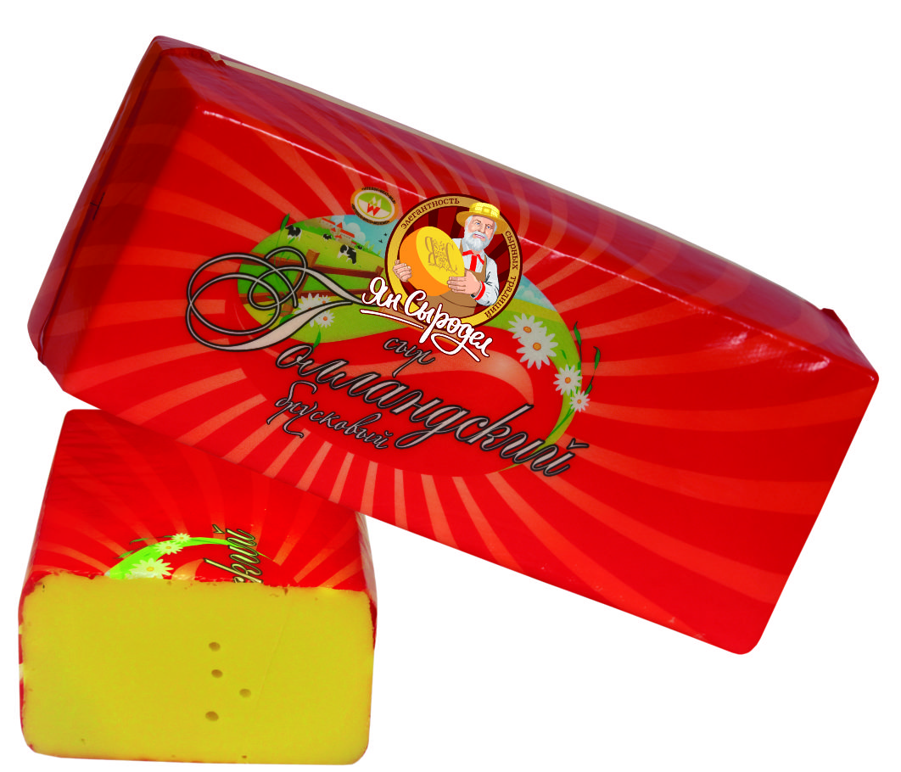 |  |  |  | Cheese “Gollandsky”  Fat content in dry solids 45% min. |  | 240 days at temperature 0-4⁰C | 2,9
The cheese is of Holland group. But «Gollandsky» differs from its congeners with less spicy taste, and more gentle consistence. Product is made in result of clotting of milk, separation and cheesy mass processing. The cheese has irregular round, oval and angular eyes in section.
Term of cheese ripening – 30 days.
Product code 0406909909 Bar-code 4811208000015
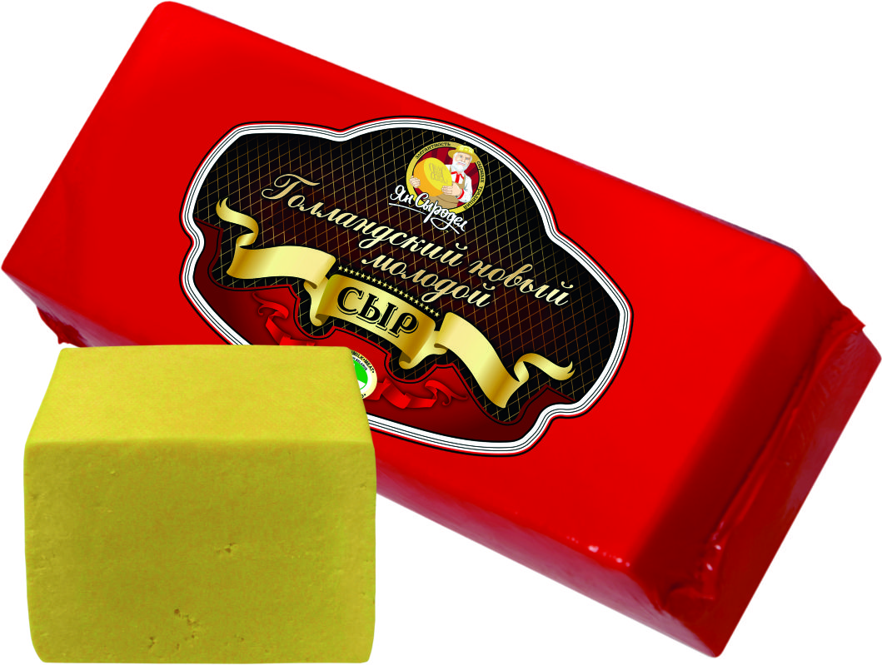  Cheese “Gollandsky novyi molodoi”  Fat content in dry solids 45% min.  It refers to the group of traditional semi-hard cheese with the low second heating temperature. It is made from normalized cow’s milk, has moderately expressed cheese smell, with slightly sour taste without strange smacks.  Term of cheese ripening – 20 days.  Product code 0406909909 Bar-code 4811208001920 |  |  |  |  |  | 240 days at temperature 0-4⁰C | 2,9
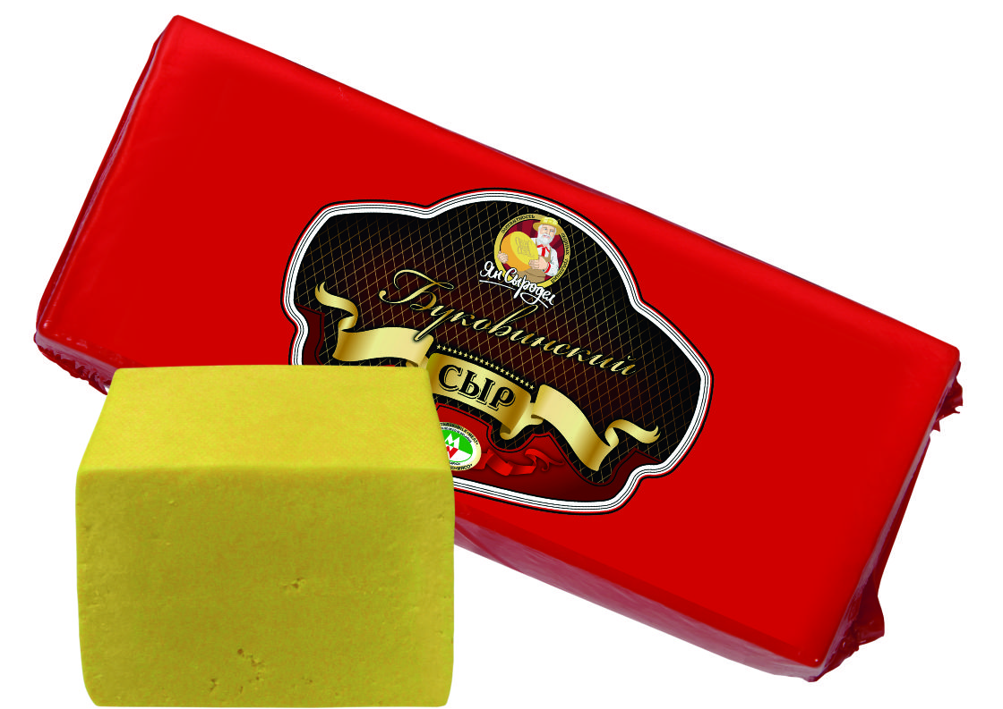 |  |  |  | Cheese “Bukovinsky”  Fat content in dry solids 45% min. |  | 120 days at temperature 0-4⁰C | 2,9
Traditional semi-hard rennet cheese. Taste and smell are slightly sour and spicy, without strange aftertaste and smells.
Term of cheese ripening – 30 days.
Product code 0406909909 Bar-code 4811208000022
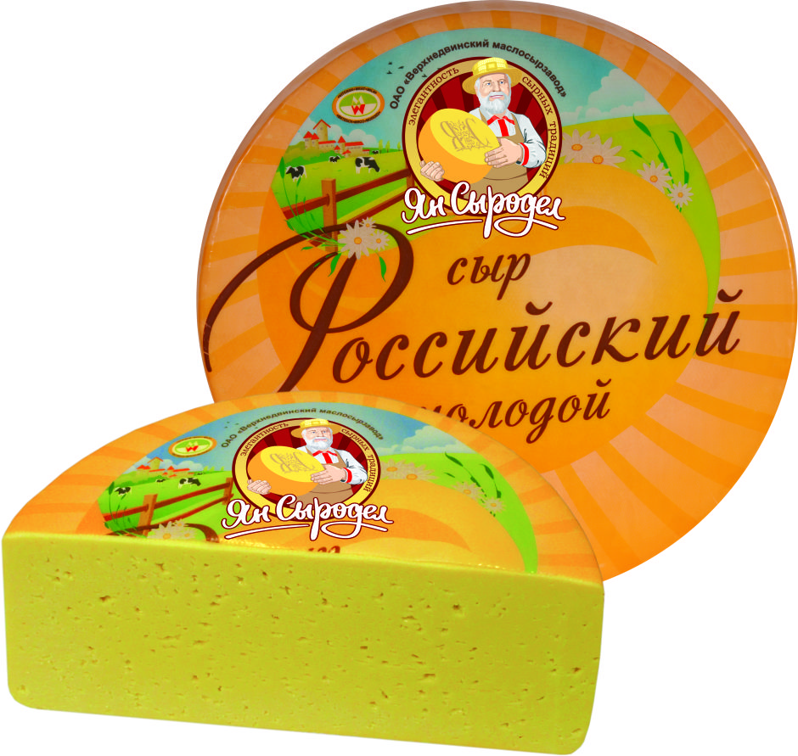 |  |  |  | Cheese “Rossiisky molodoi”  Fat content in dry solids 50% min. |  | 180 days at temperature 0-4⁰C | 3,0
It is traditional semi-hard t cheese of Russian group. The cheese has expressed cheesy, slightly sour taste. It has irregular, angular and slit-like eyes in section; the colour of the dough is light yellow to yellow.
Term of cheese ripening – 40 days.
Product code 0406909909 Bar-code 4811208001401
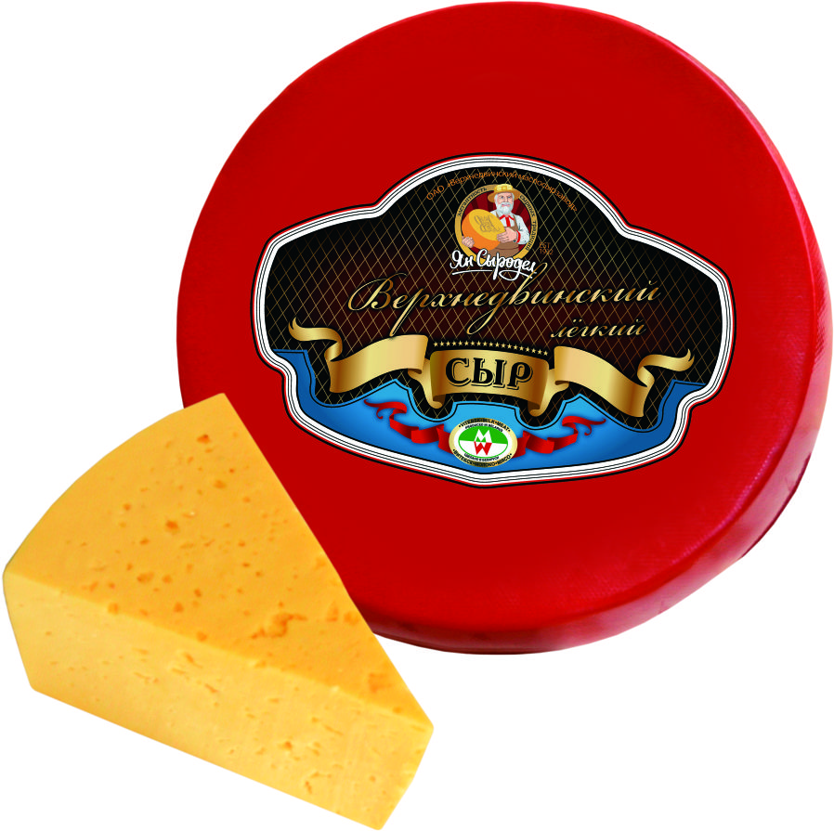 |  |  |  |  | Cheese “Verkhnedvinsky lyogky”  Fat content in dry solids 25% min. | 180 days at temperature 0-4⁰C | 2,9
The cheese has brisk cheesy taste and spicy, slightly sour smell. Colour is light yellow to yellow. Eyes are irregular angular and slit-like or round and oval. No holes and unevenness are possible in a separate cheese.
Term of cheese ripening – 30 days.
Product code 0406909909 Bar-code 4811208001425
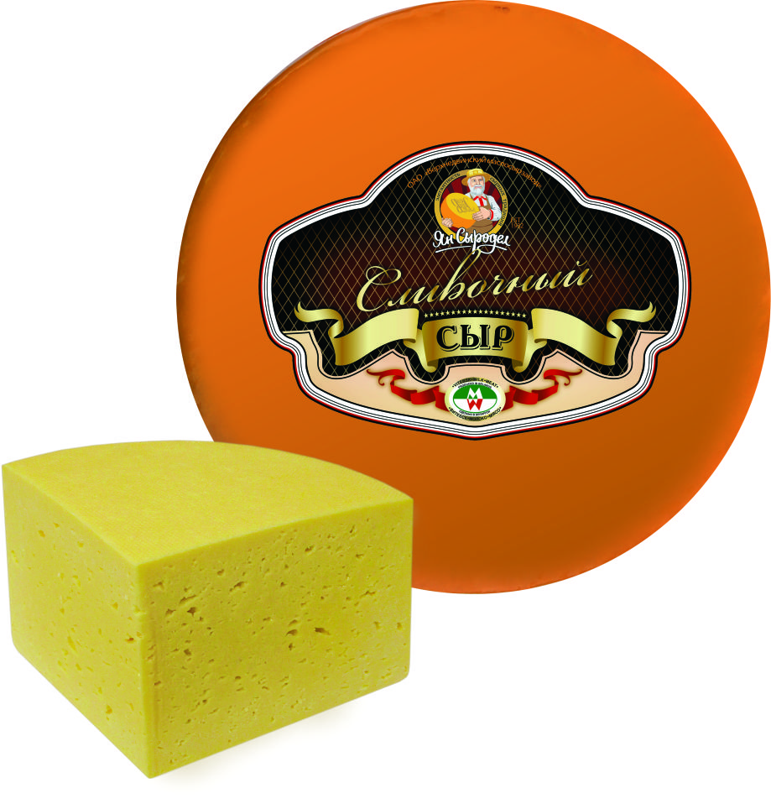 |  |  |  |  | Cheese “Slivochny”  Fat content in dry solids 50% min. | 180 days at temperature 0-4⁰C | 3,0
It is a sweet, soft, with gentle taste cheese from milk and cream, named after cream (in Russian “slivki”) “Slivochny”.
It has intensive cheese, slightly sour flavor and taste, without strange smells and tinges.
Term of cheese ripening – 25 days.
Product code 0406909909 Bar-code 4811208001487
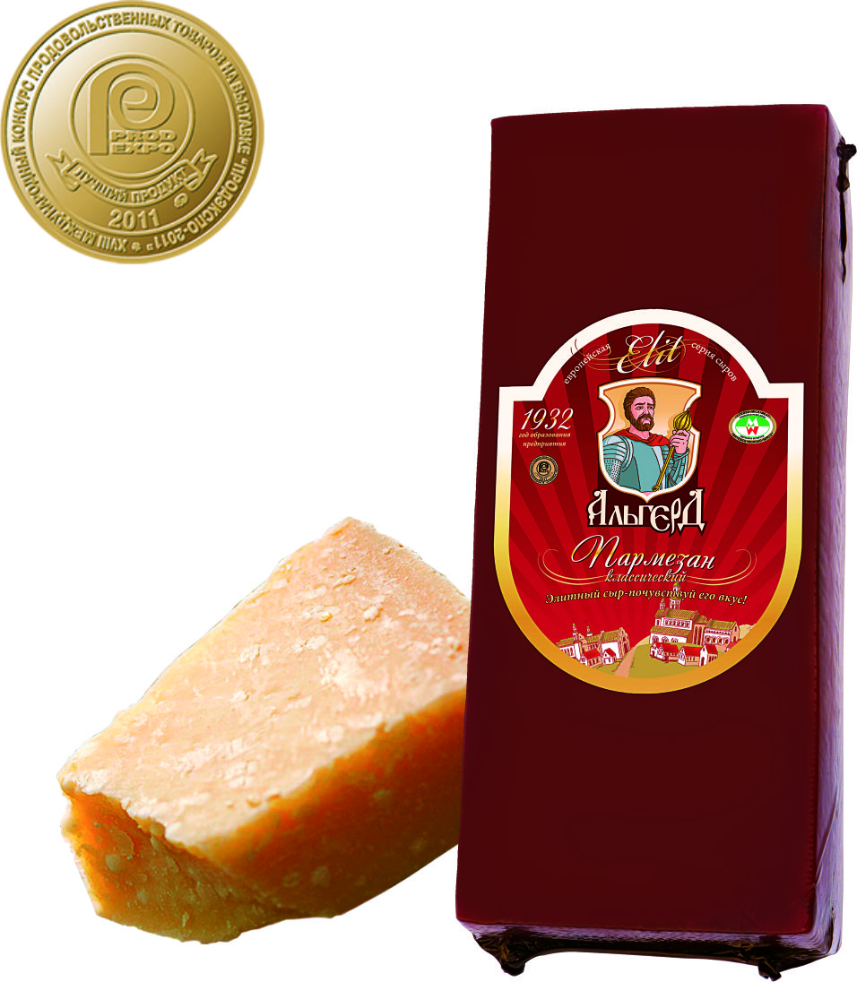 | Hard cheese “Parmezan klassichesky”  Fat content in dry solids 45% min. |  |  |  |  | 180 days at temperature 0-4⁰C | 3,5
Cheese has a taste of natural high concentrated Italian cheese Parmesan. It has a brisk smell, spicy and slightly sour taste. Eyes are irregular angular and slit-like or round and oval. No holes and unevenness are possible in a separate cheese.
The cheese can be coated in latex.
Term of cheese ripening – 90 days.
Product code 0406909909 Bar-code 4811208001623
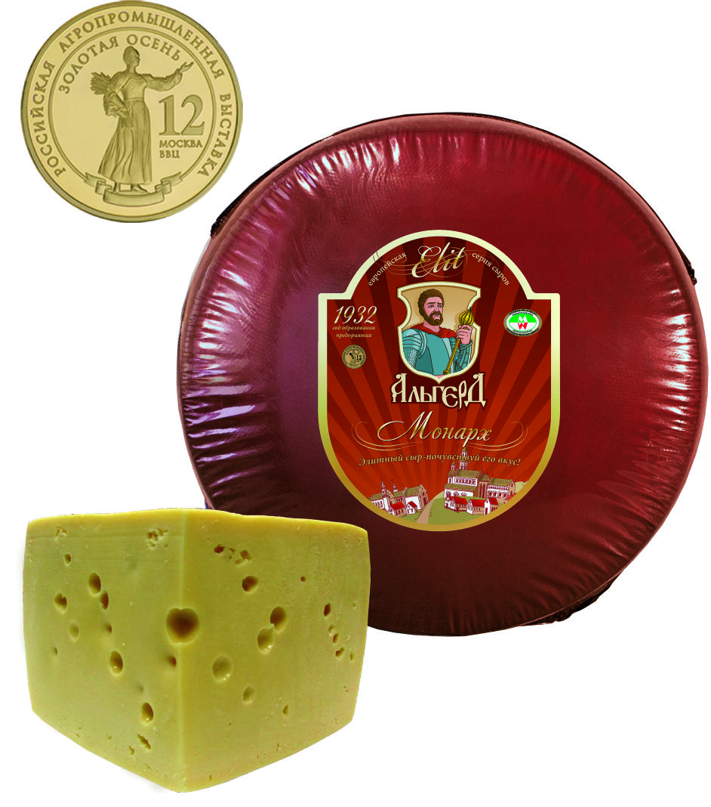 |  | Cheese “Monarh”  Fat content in dry solids 45% min. |  |  |  | 180 days at temperature 0-4⁰C | 3,4
It differs from other cheeses not only in king’s name. It belongs to elite group of semi-hard cheese thanks to unusually sweety-spicy taste with hazel aftertaste. It has regular round and oval eyes (5-15 mm) located over the whole mass of the cheese.
Term of cheese ripening – 40 days.
Product code 0406909909 Bar-code 4811208001616
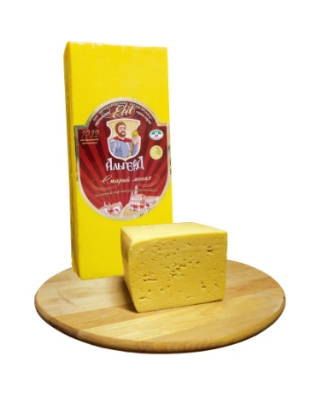  Cheese “Staryi monah”  with the aroma of baked milk.  Fat content in dry solids 50% .  Cheese refers to the elite group of semi-hard cheeses.  Taste: It has moderately expressed cheese smell and slightly sour taste with baked milk aroma.  Term of cheese maturing – 20 days.  Product code 0406909909 Bar-code 4811208004082 |  |  |  |  |  | 180 days at the temperature 0-4⁰C | 3,3
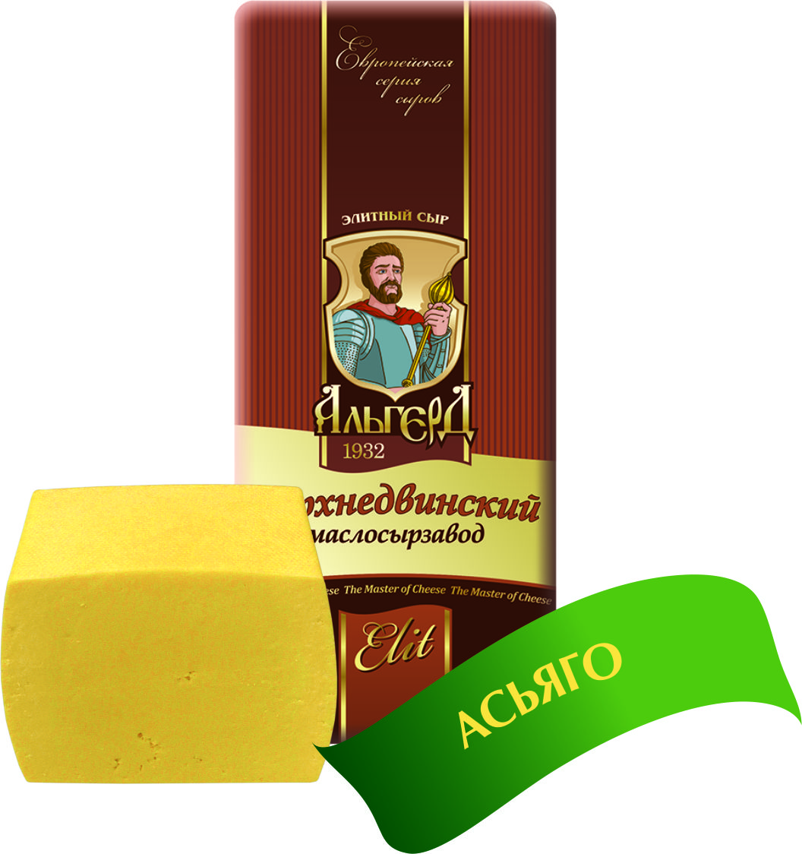  Cheese “Asiago”  Fat content in dry solids 50%.  It is a traditional Italian cheese, made from cow’s milk. Taste and smell are slightly sour and spicy, with hazel aftertaste. The cheese has round and oval eyes of different sizes in section.  Term of cheese maturing – 35 days.  Product code 0406909909 Bar-code 4811208003375 |  |  |  |  |  | 180 days at the temperature 0-4⁰C | 3,3
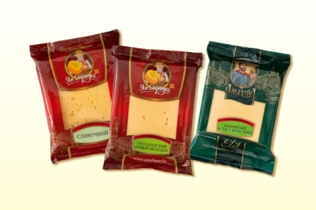  Packaged cheese in flow pack wrapper in modified atmosphere (bars from 250 till 350 grams) in assortment  Term of cheese maturing:20 - 90 days.  Product code 0406909909  Product code 0406908700  Quantity in a packing case (kilo) : 3 |  |  |  |  |  | 180 days at the temperature 0-4⁰C | 3,5-4,2 per kilo  (depending on the kind of cheese)
Cheese in assortment sliced (in gas environment)  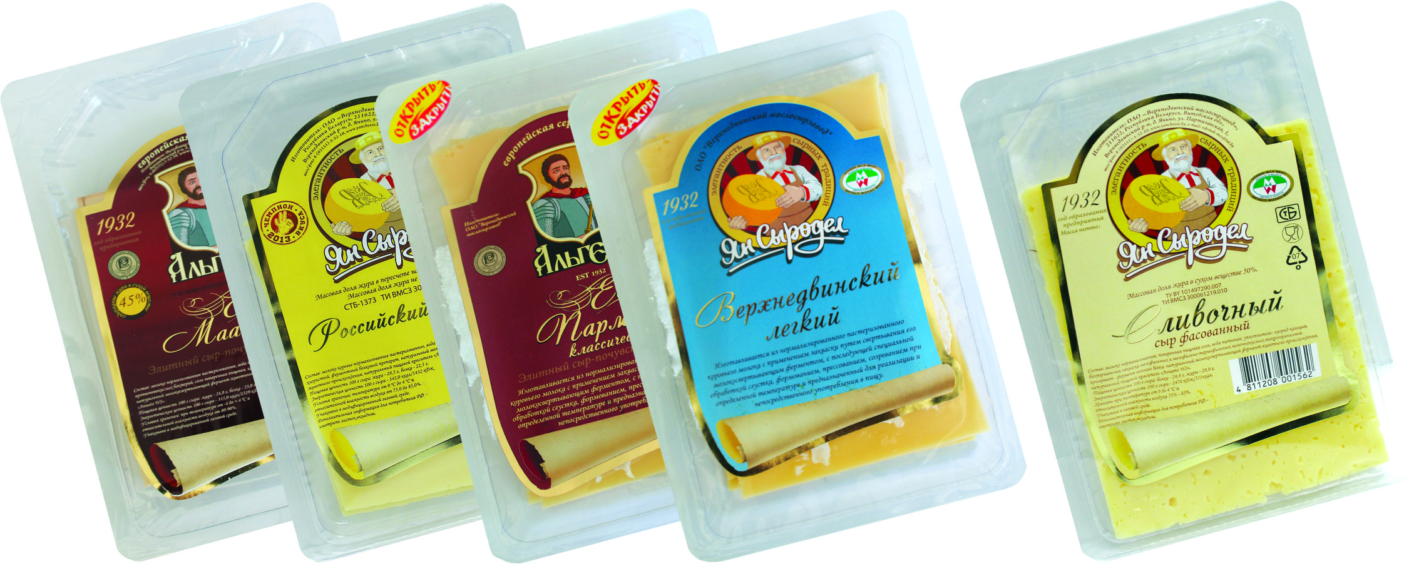  - Fat content – 45-50%  - Net weight - 154g  - Packaging - Multilayer plastic package  Quantity in a packing case: 9 pieces (1,3 kilo)  Product code 0406909909  Product code 0406908700 |  |  |  |  |  | From 90 till 240 days at the temperature 0-4⁰c(depending on the kind of cheese) | 0,5-0,6 for 1 piece  (depending on the kind of cheese)
Butter Krestianskoe Fat content 72,5 %  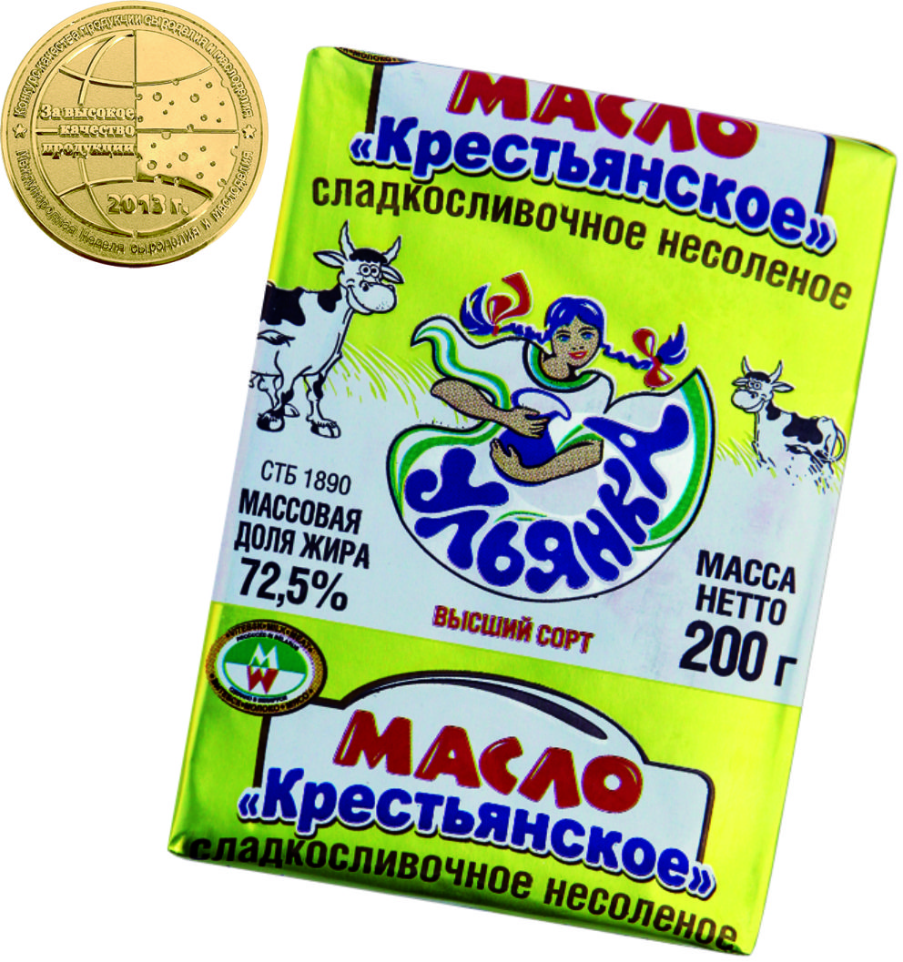  Unsalted sweet-cream butter “Krestianskoe”  has gentle taste and aroma. Net weight – 180 g.  Packaging – foil.  Quantity in a packing case: 20/40/80  Product code 0405203000  Bar-code 4811208004129 |  |  |  |  |  | 180 days at the temperature from  -3 till -9 ºС | 2,4 per kilo  0,7 for 180 g
Butter Sladkoslivochnoe Fat content – 82,5%  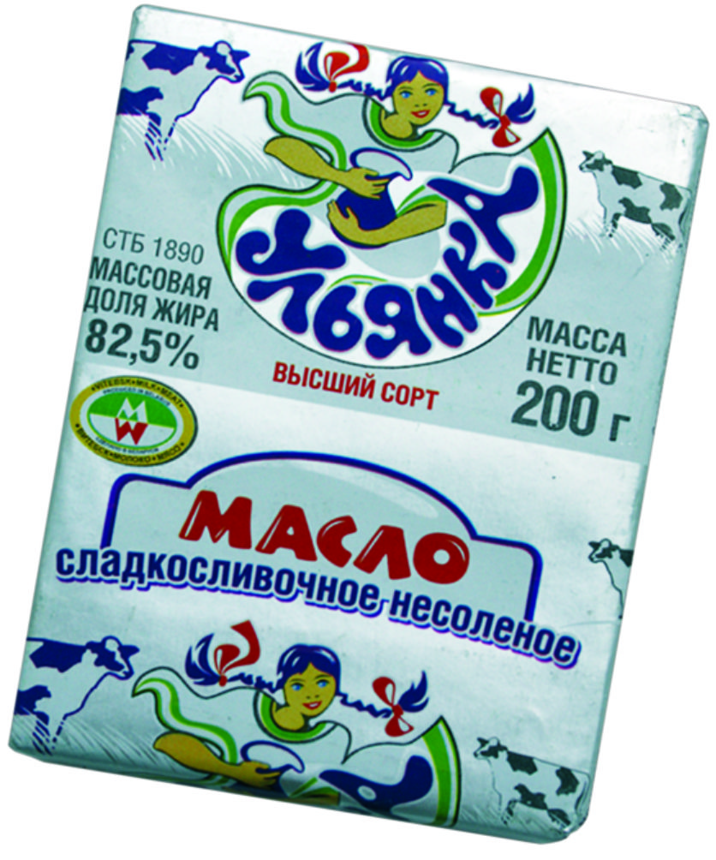  It is a real sweet-cream butter  without vegetable fats and preservatives.  Quantity in a packing case: 20/40/80  Product code 0405101900  Bar-code 4811208004570 |  |  |  |  |  | 180 days at the temperature from  -3 till -9 ºС | 2,7 per kilo  0,7 for 180 g

Besides we’d like to draw your attention to another our product – whey powder:
№ | List of items produced | Price per kilo*, no VAT included, FСА delivery basis, USD | Technological documents
1 | Whey powder | 0,7 | TU RB 100098867.219.2007
2 | Demineralized cheese whey powder with degree of demineralization 50% | 0,7 | TU RB 100098867.219.2007
3 | Demineralized cheese whey powder with degree of demineralization 70% | 0,8 | TU RB 100098867.219.2007
4 | Demineralized cheese whey powder with degree of demineralization 90% | 1,0 | TU RB 100098867.219.2007
*The price is approximate and is to be considered individually.
Specifications:
Indicator name | Demineralized whey powder «SD-NF» | Whey powder
Organoleptic characteristics
Name of TNPA | TU RB 100098867.219-2007 | TU RB 100098867.131-2001
Form  Visual appearance | dry finely pulverized powder | homogeneous, small, dry powder
Colour | from white to creamy | from white to yellow
Taste and smell | wheyish, sweet, without foreign flavors | saltish-sweet, similar to milk whey powder
Physical and chemical characteristics
Lactose, %, min. | 70 | 65,0
Protein, %, min. | 11,0 | 11,0
Moisture, %, max. | 5,0 | 5,0
Ash,%, min. | 6,0 | -
Malic acid (titratable acidity) | 25,0 | 25,0
Titratable acidity, sm³ of primary sludge, max. | 1,0 | 0,6
Microbiological properties
KMAFAnM | 1,0×10⁵ | 1,0×10⁵
BGKP in 1,0 g | not allowed | not allowed
Listeria monocytogenes in 25 g of product | not allowed | not allowed
S. aureus, in 1,0g | not allowed | not allowed
pathogenics, including salmonnels, 25,0g | not allowed | not allowed
yeasts, КОЕ/g, max. | 50 | 50
must, КОЕ/g, max. | 100 | 100
Shelf life
6 month from the date of producing
Storage
 | store at temperature from 0 to 20 ^{о}С and by relative humidity 85% max. | store at temperature from 0 to 20 ^{о}С and by relative humidity 80% max.

