QUOTATION OF JSC “POLOTSK-STEKLOVOLOKNO” FOR SUPPLY OF EXPORT ORIENTED PRODUCTS

I. Company details:

Company name:
Full name: Joint Stock Company “Polotsk-Steklovolokno”
Short name: JSC “Polotsk-Steklovolokno”

Focus of business: production of fiberglass and products on its basis

Address:
211400, Stroitelnaya Str. 30, Vitebsk region, Polotsk, Belarus
Tel.: +375 214 41 55 51
Fax: +375 214 41 54 04

II. Brief information about JSC “Polotsk-Steklovolokno”

JSC “Polotsk-Steklovolokno” is one of the leading manufacturers of fiberglass materials in the world. This is a modern, dynamically developing industrial complex with an area of 1 million square meters holding more than a thousand units of state-of-the-art equipment.

JSC “Polotsk-Steklovolokno” is an integrated enterprise which unites in a uniform complex the technological processes of raw materials preparation, glass melting, forming of fiberglass and its textile processing, finishing treatment of glass fabrics and production of glass reinforced plastics (GRPs). This allows for the enterprise to be stable, flexible, provide for the markets with a wider range of products, promptly react to enquiries and wishes of customers and be a step ahead of the market requirements.

JSC “Polotsk-Steklovolokno” is an export-oriented company which has business with over 45 countries worldwide. The company is integrated into the world economy by means of timely and highly qualified fulfillment of orders for automotive industry, electronics, military-industrial complex, building and other industries. We manufacture products on the basis of various kinds of glasses, namely alumoborosilicate "E" glass, silica glass meant for high temperature insulation, and high-strength VMP glass.

III. Range of products with customs tariff numbers specified
JSC “Polotsk-Steklovolokno” specializes on the production of the following products:

- Electric insulation glass fabrics – customs tariff number 7019520000, 7019590000;
- Building materials (glass fabrics, glass meshes) - customs tariff number 7019520000, 7019590000;
- Silica materials (glass fabrics – customs tariff number 7019520000, 7019590000;
glass meshes – customs tariff number 7019520000, 7019590000; fiber – customs tariff number 7019199009, ready-made articles – customs tariff number 7019909900);
- Fabrics for glass reinforced plastics – customs tariff number 7019520000, 7019590000;
- Thermal insulation materials – customs tariff number 7019390009;
- Glass yarns – customs tariff number 7019191009;
- Rovings – customs tariff number 7019120000;
- Hollow fibers and fabrics on their basis – customs tariff number 7019520000, 7019590000;
- Chopped fiber – customs tariff number 7019199009;
- Articles made of glass reinforced plastics.
IV. Description of products and fields of application:
- Mining and process industries.
We see here good perspectives for selling glass meshes and silica meshes.
SSF glass meshes are used for filtration of exit gas in manufacturing of carbon black, for filtration of liquid aluminium and its alloys.
Silica meshes are made of high temperature silica fiber with SiO₂ content not less than 94% (they can be used on long term basis, retaining their properties at temperatures up to 1000 ⁰С and on short term basis at higher temperatures).
Field of application: silica meshes are used for making filters to clean melts of ferrous and nonferrous metals (aluminium, magnesium, and other alloys; different grades of iron and steel) while pouring them into moulds.
Advantages of using filters made of silica meshes:
- Reduced molding defects by 1,5-2 times;
- Improved metal structure;
- Increased physical-mechanical properties.
A filter of a required size is cut out and installed into a molding system or directly under a molding channel between the lower and the upper frames of a mold.
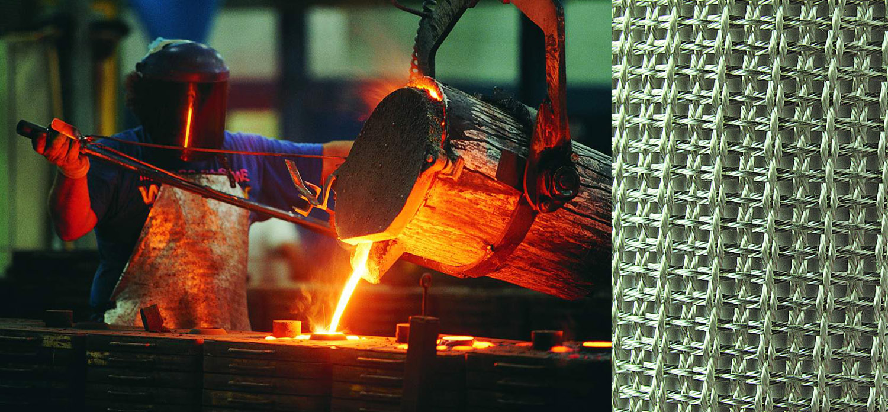
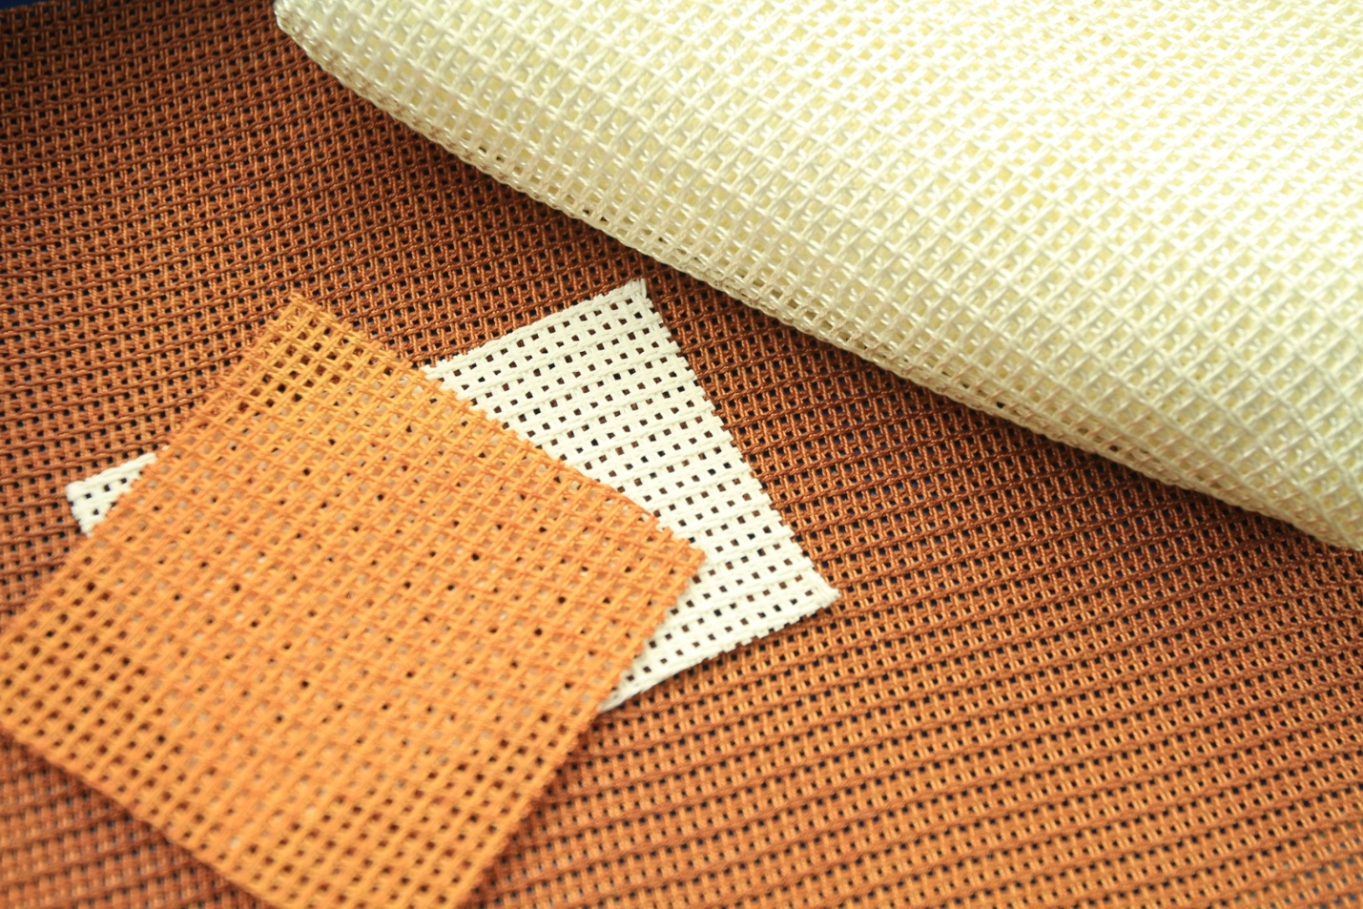
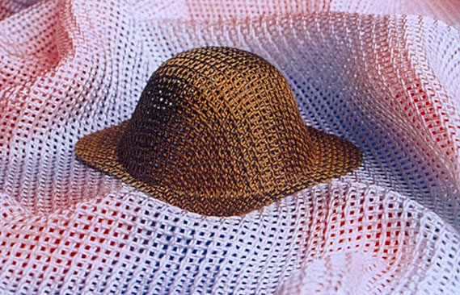

2. Machine building and automotive industry
We believe that there are perspectives for selling our silica fiber in the automotive industry as well as in a number of other industries.
Silica fiber is made of glass no. 11 (SiO2 content 94-96%, operating temperature is up to 1000 ⁰С), and Puresil glass (SiO2 content is over 98%, operating temperature is up to 1200 ⁰С).
Fields of application:
- Silica fiber is used for fabricating needle punched material which is widely used as an insulating material in automotive industry (for instance, for insulation of mufflers), metallurgy, at atomic and thermal power stations, and for insulation in electric and open-flame ovens.
- Silica fiber is also used during sewing of thermal insulation mats: silica fiber is in the shell made from silica fabric.
Whereas chopped silica fiber is used for production of high temperature reinforced composites, for making silica paper, and as a reinforcing material in production of different friction articles.
It is also possible to use E-glass needle punched material in automotive industry for sound insulation in motor area.
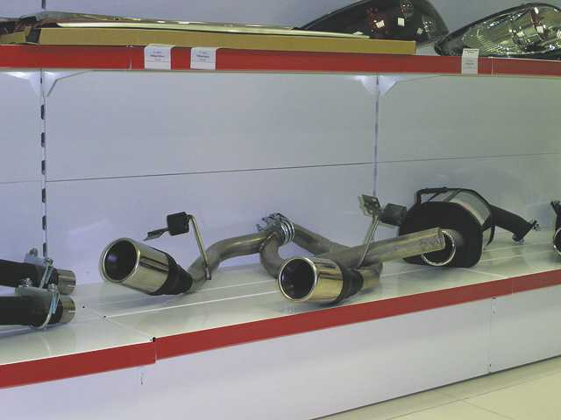
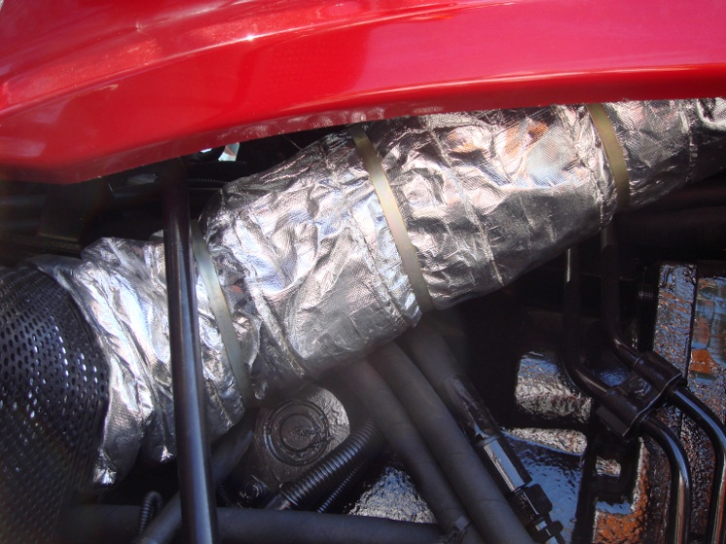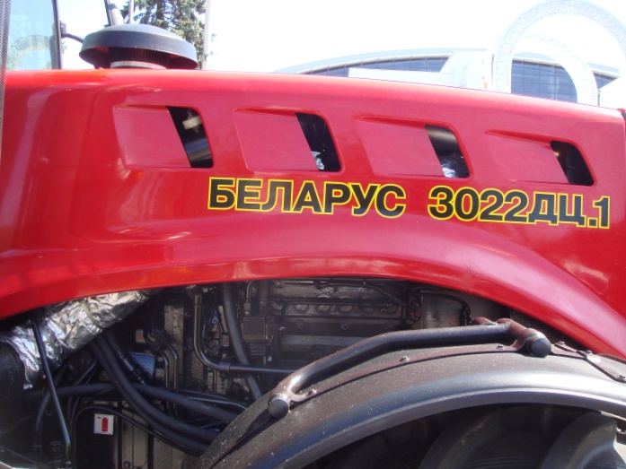

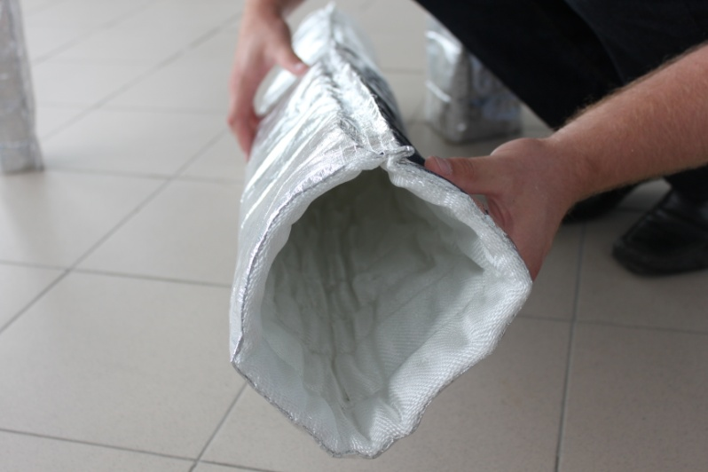

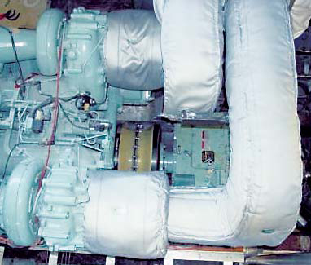
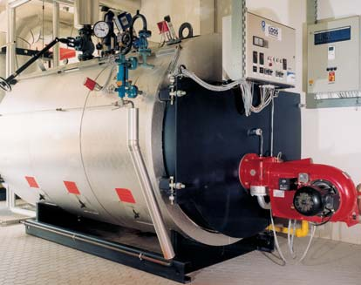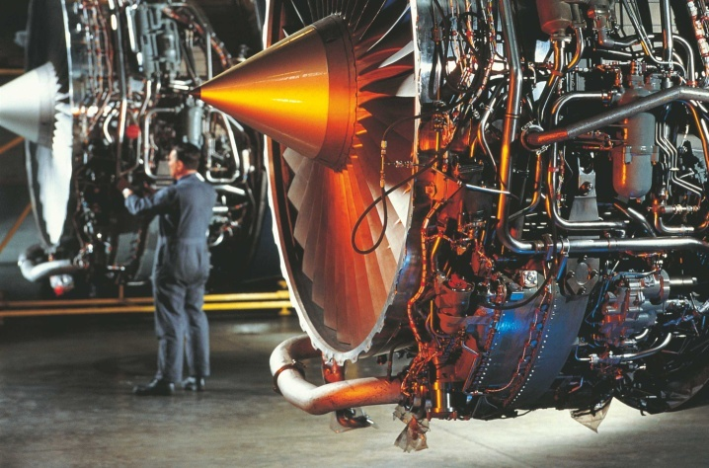
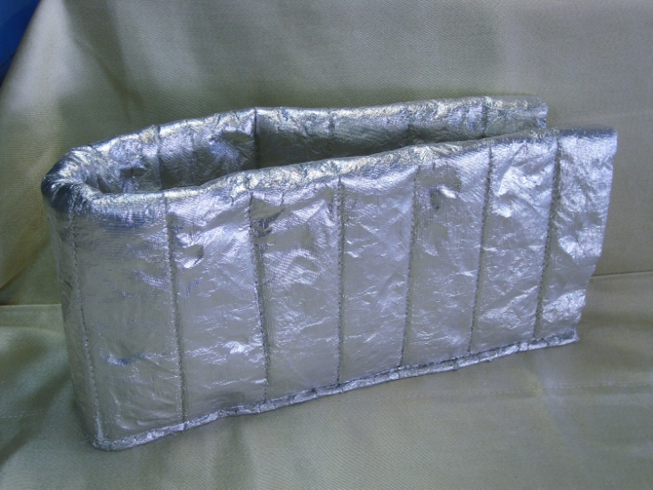
We see good perspectives for selling our silica fabrics for railway carriages production sector. Silica fabrics are used for high temperature insulation in fire protective shutters, cable insulation.
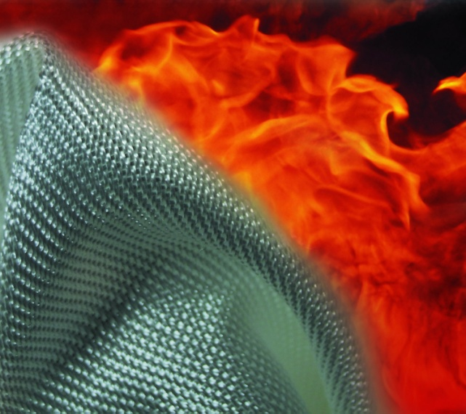
3.Shipbuilding and car-building industry.
In a shipbuilding sector we see the perspectives for selling different types of our fabrics for glass reinforced plastics.
- Fabrics for glass reinforced plastics (Е-glass) of different weights and weave types are widely used both in big and small shipbuilding. These fabrics are used for production of composites from which bodies, walls for vessels, boats, yachts etc. are further manufactured.
- Fabrics for glass reinforced plastics are also used for production of composites from which radiotransparent crowns are manufactured.
Our fabrics for glass reinforced plastics are also used in aerospace industry. For instance:
- Helicopters sector. Fabrics for the production of glass reinforced plastics are used for making such helicopter elements as cabin modules, blades.
- Rockets sector. Fabrics for glass reinforced plastics are used for production of composites from which glasses are further made.
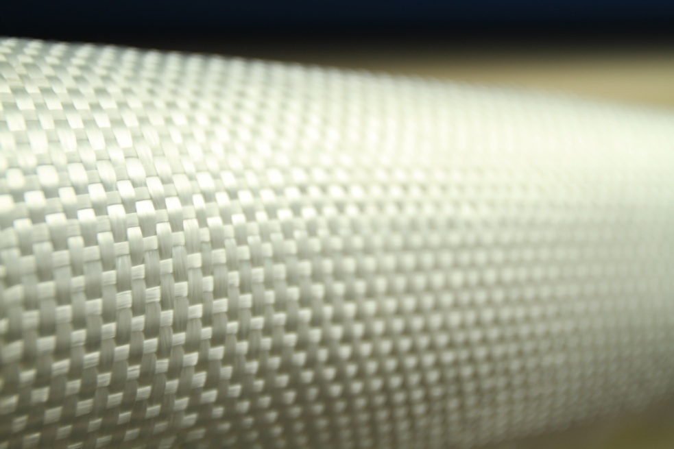
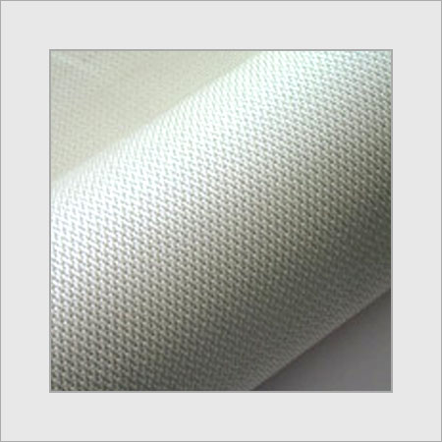

4. Chemical industry
Our high temperature silica fabrics are likely to be used here as a means of industrial hyper thermal isolation.
In general we see good potential for our high temperature silica fabrics which can be used in different industries.
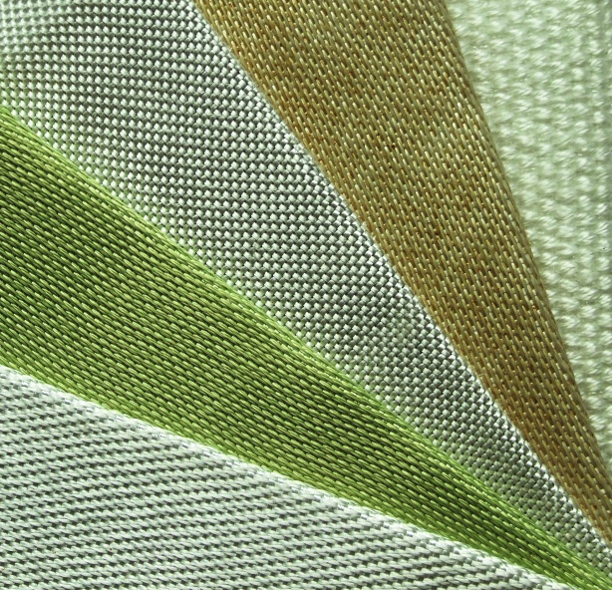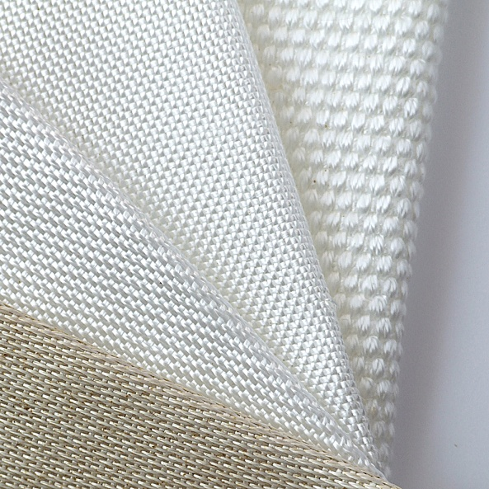
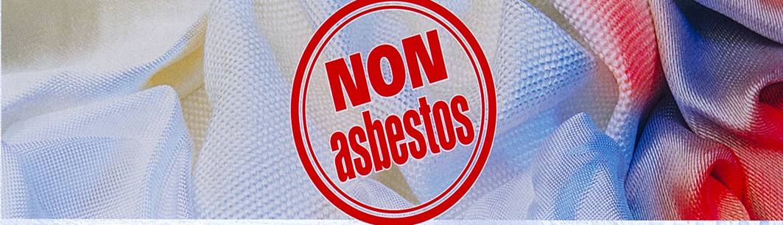
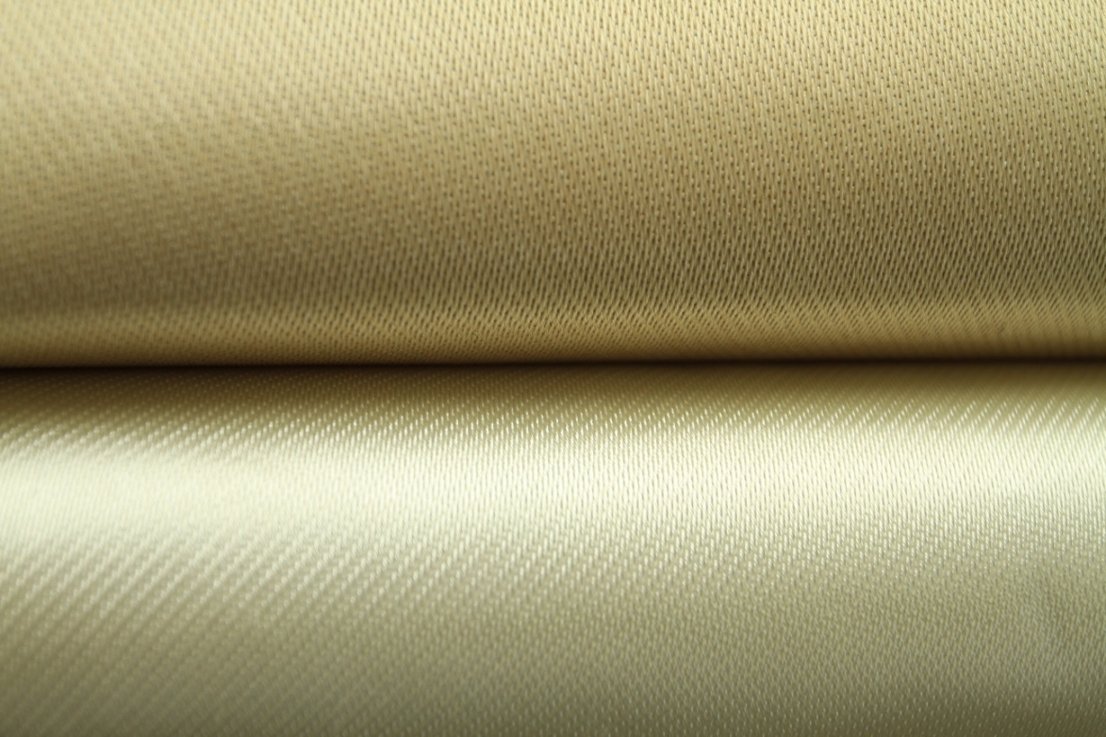
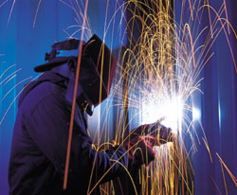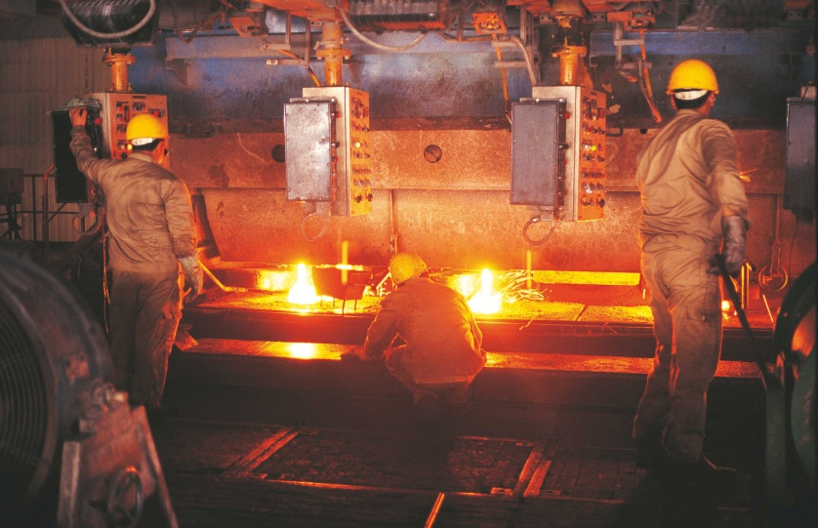

Fire blanket
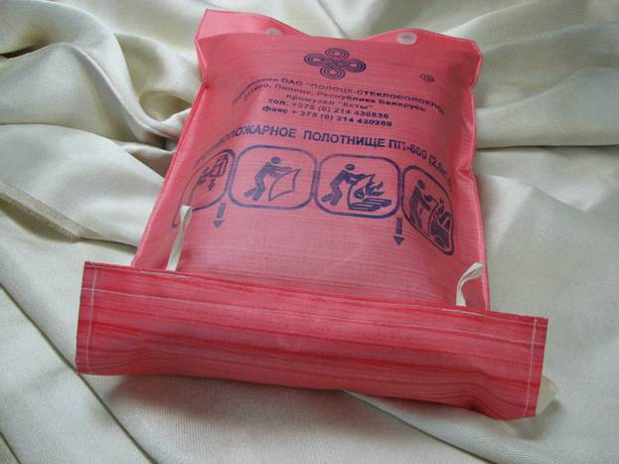

Fire protective curtains
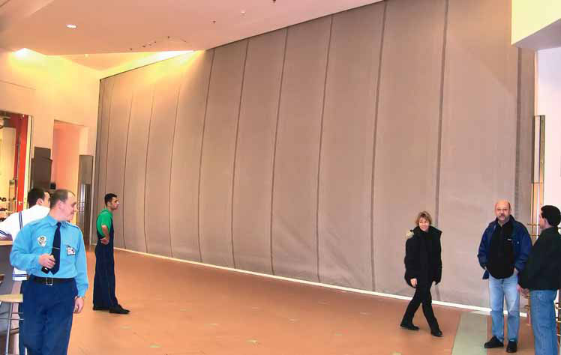

Thermal insulation jacket made of fabric for glass reinforced plastics
A thermal insulation jacket for multiple use is an excellent item for thermal insulation of a wide range of equipment: heat exchangers, valves, parts of tubes, pumps, safety fittings and others. It is made of heat-resistant materials (glass fabric inside and glass fabric impregnated with silicone outside, filler is a needle punched thermal insulation materials) and can be used at temperatures up to 350^{о}С, on a short term basis – up to 450^{о}С.
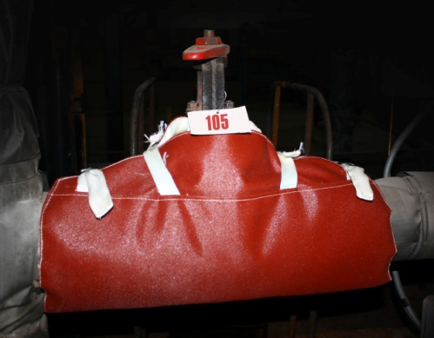
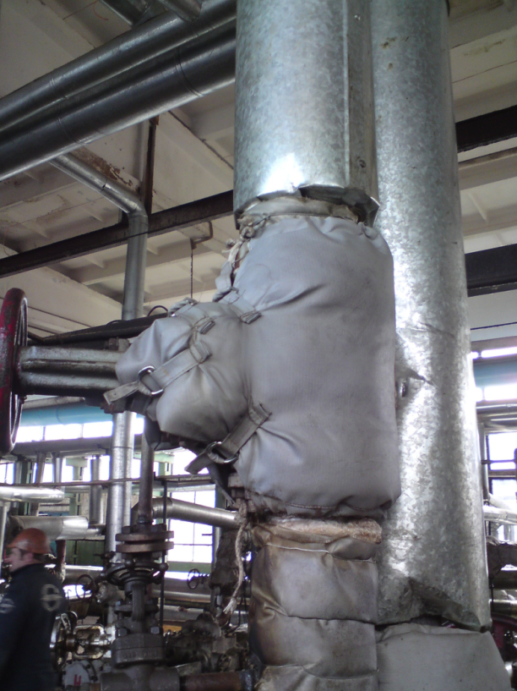

We produce E-glass needle punched material for thermal insulation of pipes and equipment.

It is possible to use fabrics for glass reinforced plastics with silicone to fabricate flexible air duct fuse elements in different industries where air ducts with hot air are involved (for instance, chemical industry, etc.).
Use of high temperature silica materials (needle punched mat from silica fiber) is possible in atomic power engineering and at thermal power stations.
However, please note, that in many cases fiberglass products are semi finished products meant for production of ready-made articles used in different industries. Therefore, it is necessary to look for potential customers directly among manufacturers of those articles (glass reinforced plastics, needle punched mats from silica fiber and others). We produce a number of ready-made articles ourselves (thermal jackets, fire blankets, sleeves for insulation of mufflers).
V. Key parameters of our silica fabrics
- replacement for asbestos;
- our own existing technology of production of silica allows us to produce fiber with SiO2 content not less than 98% for fiber of grade Puresil.
- silica articles are inert to the majority of chemical agents, resistant to organic and mineral acids of any concentrations even at increased temperature;
- possess high chemical resistance to water and high pressure steam;
- are able to absorb moisture, but do not split in the presence of water;
- stable in vacuum.
VI. The main competitive advantages of our products include:
- a wide range of products which makes it possible to use fiberglass materials in different fields;
- a possibility to develop new products or improve regular items in our own R&D;
- stable high quality of products;
- Quality Management System conforms ISO 9001:2009;
- more attractive prices if compared with other manufacturers;
- a possibility to arrange speedy delivery of the goods “from door to door”.
VII. Prices and terms of delivery
Making quotations always requires clarifications of technical parameters which is stipulated by the specific character of fiberglass based materials (the existence of different product modifications depending on application), and volumes of consumption. We are willing to offer any terms of delivery which are most convenient for the customer, and we can also offer a minimum order quantity, namely from one roll of glass fabric/ one box of fiber (yarn). Sales terms are based on direct negotiations with signing a sales contract in the end.
VIII. Contact person details:

Regional Manager
Valery Padalitsa
Tel: +375214415668
Fax: +375214430836
E-mail:padalitsa@psv.by

Engineer, Marketing Department
Natalty Lobastova
Tel.: +375-214-415673
Fax: +375-214-415420
E-mail: Lobastova@psv.by

